UNIVERSITY OF ENGINEERING AND TECHNOLOGY TAXILA
Department of Industrial Engineering & of
Final TERM PAPER
SUBJECTIVE

Course Name: Metrology & Statistical Quality Control Course Code: IE 312
Semester: 5th (Entry 2011) Course Instructor: Engr. Zaheer Ahmad
Time Allowed: 2:30 hrs Marks: 30
All Questions carry equal marks (Each Question=6)
Question No. 2
- Explain the Procedure for the construction of a C-Chart?
- What are the Objectives of Variable Control Charts?
Question No. 3
Control charts for X-Bar and R are to be established on a certain dimensions of Slip Ring Diameter (cm). Data are collected in subgroup size of 5 and are given below. Determine trial central line and control limits also revise the central line and limits?
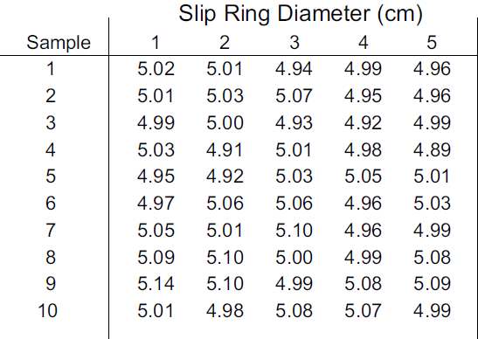

Question No. 4
Determine the equation for the OC Curve for the sampling plan N=6000, n1=80, c1=2, r1=4, n2=160, c2=5, r2=6. Construct the curve using about 3 Points.
Question No. 5
Define the following with the examples?
Precision, Accuracy, Bar Graph, Polygon of Data, Ogive
Question No. 6
- Write a Comparison between Control Charts of Variables vs. Control Charts of Attributes?
- Write Pros & Cons of the Acceptance Sampling?

